**Word Integration Specification**

ModelWriter

Text & Model-Synchronized Document Engineering Platform

Work Package: WP6

Edited by:

Etienne Juliot <etienne.juliot@obeo.fr> (OBEO)

Marwa Rostren <marwa.rostren@obeo.fr> (OBEO)

Yvan Lussaud <yvan.lussaud@obeo.fr> (OBEO)

Date: 5-June-2015

Version: 1.0.0

Apart from the deliverables which are defined as public information in the Project Cooperation Agreement (PCA), unless otherwise specified by the consortium, this document will be treated as strictly confidential.

Document History

|  |  |  |  |
| --- | --- | --- | --- |
| Version | Author(s) | Date | Remarks |
| 0.1.0 | Etienne Juliot  Marwa Rostren | 29-Apr-2015 | Draft |
| 1.0.0 | Marwa Rostren  Yvan Lussaud | 5-June-2015 | Initial Release |
|  |  |  |  |

Table of Contents

Document History 2

1. Introduction 4

2. Desynchronization 5

2.1. UX Proposition 5

3. Document Generation Template 6

3.1. UX Proposition 6

1. Introduction

This document details the ModelWriter Integration inside Word for non IT users (typical users).

Objective 1: Display the de-synchronization information in the authoring tool (Word)

Objective 2: Document Generation

1. De-synchronization

We assume that the user has already written his documentation using Word authoring tool.

The wanted scenario concerning the de-synchronization is as follows:

1. The user launches MW product, independently of the Microsoft Word tool, in order to realize the mapping and in order to analyze the document later to compute de-synchronization issues.
2. We suppose that Word tool must contain a specific “ModelWriter” area like a ribbon which disposes of several actions like activating the de-synchronization verification and document regeneration etc.
3. The user can activate the de-synchronization verification in Word. To make this de-synchronization verification possible, the user has to connect the opened document to a local or a remote MW KB where some text parts of the current document has been already mapped to models concepts using the MW Editor.
4. Inside the Word tool, some markers illustrating the de-synchronization issues appear for a text part that we call later a “block”. A block can represent a section, a paragraph, a table, a cell table, a sentence or a word and so on. The marker should be associated to a message describing which element of the model has been modified, related to the associated block of documentation (example: « The name of this library has been modified "Amazon" → "Amazing"). The same block can be concerned by several markers.
5. The user can validate a marker with or without modifying the relative block. It is up to him to make the decision of updating the existing text or validating the marker. In both cases, the marker disappears.
   1. UX Proposition

The revision system of Word seems to fit the ergonomic requirement of this feature. It could be interesting to reuse this existing system and automatically create review markers relying on the MW synchronization results.

The feature can also be done by creating other markers dedicated system inspired from this review user experience.

1. Document Generation Template

Some existing technologies ensure the generation of documents from models, but they require some technical skills. A typical word user should be able to create his own generator easily without any need to special technical skills.

First version:

1. The user activates the MW ribbon and connects to a local or remote a KB or the model.
2. The user can insert a diagram. The list of available diagrams appears and the user can now choose which diagram to insert. The inserted diagram must display a flag to indicate if this diagram is automatically refreshed or not (as like as the existing feature of Word for special Paste: with Copy/Paste & Copy/Paste with Link).
3. The diagram will be inserted to the document as a PNG image.
4. The user can insert a table, a tree or a cross table using a similar manner as for the insertion of diagrams.
   1. UX Proposition

The existing « insert object » feature of Word could satisfy a part of this requirement.

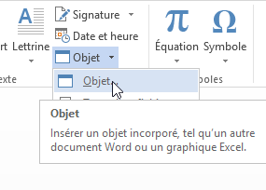

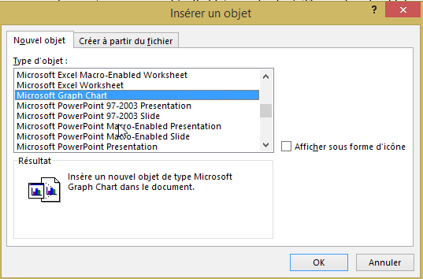

To display text parts which are linked to models concepts the developer sheet in Word provides some interesting features as the “creation mode” which allows highlighting a part of a text (see the next figure)

